Early Multimodal Physiological Phenotypes and Outcomes in Aneurysmal Subarachnoid Hemorrhage: An Unsupervised Machine Learning Clustering Study Based on MIMIC‑IV Cohort
部分内容由豆包生成

Abstract

Background
Aneurysmal subarachnoid hemorrhage (aSAH) is a severe neurocritical disease accompanied by multi-system physiological disturbances within 48 hours of ICU admission. Early anemia is a common complication, yet patients with identical hemoglobin levels present highly heterogeneous prognosis. Single hemoglobin indicators cannot explain this prognostic difference, and previous studies lack multimodal physiological stratification based on data-driven algorithms. The original research focusing on red blood cell transfusion was abandoned due to extremely small transfusion sample size, and this study reconstructed the framework to identify early physiological phenotypes via unsupervised machine learning and explore phenotype-dependent prognostic effects of early anemia.

Methods
This single-center retrospective observational study extracted data from MIMIC‑IV v2.2 database, enrolling 229 adult aSAH patients meeting unified inclusion and exclusion criteria. Eight core multimodal physiological indicators covering anemia, neurological function, circulation, tissue oxygenation, renal function and coagulation were collected within 0–48 hours after ICU admission. K-means unsupervised clustering combined with elbow method and silhouette coefficient was used to determine optimal clustering number K=4. Hierarchical clustering was adopted to verify clustering stability via adjusted Rand index (ARI). Baseline characteristics, short-term prognostic endpoints (in-hospital mortality, ICU mortality, length of stay) were compared across four phenotypes. Stratified analysis and interaction test were performed to clarify heterogeneous predictive effects of early anemia (Hb_min <10 g/dL) on in-hospital mortality in distinct phenotypes. Multiple statistical tests including Kruskal-Wallis H test and Chi-square test were applied, all two-tailed P<0.05 defined as statistical significance.

Results
1. Clustering validity: K=4 was confirmed as optimal cluster number. ARI between K-means and hierarchical clustering reached 0.738, indicating favorable clustering stability. Four phenotypes with distinct physiological characteristics were identified: Phenotype 1 (mild physiological disturbance, n=82), Phenotype 2 (isolated neurological critical injury, n=49), Phenotype 3 (circulatory dysfunction phenotype, n=47), Phenotype 4 (mixed multiple organ critical failure, n=51).
2. Phenotype prognostic gradient: In-hospital mortality increased sequentially across phenotypes: Phenotype1 (1.22%), Phenotype2 (16.33%), Phenotype3 (14.89%), Phenotype4 (31.37%). Chi-square test confirmed significant inter-group mortality difference (P<0.001).
3. Phenotype-dependent effect of early anemia: Stratified analysis showed anemia carried distinct mortality risk in different phenotypes. In Phenotype1, anemic patients mortality 9.09% vs non-anemic 0%; Phenotype2 anemic mortality 33.33% vs non-anemic 13.95%; Phenotype3 anemic mortality 33.33% vs non-anemic 6.25%; Phenotype4 anemic mortality 32.00% vs non-anemic 30.77%. The interaction term between anemia and physiological phenotype was statistically significant (P<0.001).
4. Physiological inter-group difference: All eight core clustering indicators exhibited significant differences among four phenotypes (all Kruskal-Wallis P<0.001). Phenotype4 showed the lowest hemoglobin, worst neurological function, severe circulatory shock, elevated lactate and creatinine, consistent with multiple organ dysfunction pathophysiology.

Conclusions
Four stable early multimodal physiological phenotypes of aSAH patients were identified via K-means clustering with progressive adverse prognosis gradient. Early anemia is an independent adverse prognostic factor in isolated neurological critical phenotype and circulatory failure phenotype, while its predictive value is limited in mild disturbance and mixed multi-organ failure phenotypes. Physiological phenotyping based on routine ICU monitoring indicators can realize individualized risk stratification and provide evidence for phenotype-targeted anemia intervention strategies for aSAH patients.
Keywords: aneurysmal subarachnoid hemorrhage; physiological phenotype; unsupervised machine learning; K-means clustering; early anemia; prognostic stratification; neurocritical care

1 Introduction

1.1 Clinical Background of Aneurysmal Subarachnoid Hemorrhage
Aneurysmal subarachnoid hemorrhage (aSAH) is an acute critical neurocritical illness predominantly attacking young and middle-aged adults, featured by acute onset, high all-cause mortality and long-term disability, imposing heavy medical and social economic burdens. Within the first 48 hours after ICU admission, patients suffer superimposed multi-system physiological disorders: primary intracranial injury leads to neurological deterioration, accompanied by secondary complications including circulatory instability, tissue hypoxia, early anemia, systemic inflammatory response and acute renal injury. The compound effect of these early systemic disturbances is the core driver of short-term poor outcomes of aSAH.
Early anemia is one of the most prevalent ICU complications of aSAH, induced by acute stress-mediated erythropoiesis suppression, repeated minor intracranial hemorrhage, surgical trauma and hemodilution after aggressive fluid resuscitation. Multiple previous cohort studies verified that early anemia correlates with elevated mortality of aSAH. However, prominent clinical heterogeneity exists: patients with identical hemoglobin severity present completely different clinical trajectories. Some patients maintain stable vital signs, while others rapidly progress to multiple organ dysfunction syndrome (MODS) or death. Single hemoglobin measurement cannot interpret such divergent prognosis, indicating the necessity of integrating multi-dimensional physiological background to evaluate the risk of anemia.

1.2 Limitations of Prior Research
Existing studies focusing on aSAH early anemia and physiological disturbance have four major defects:
- Most studies only adopt univariate analysis of hemoglobin, GCS or SOFA score, separating the intrinsic correlation between neurological injury, circulatory perfusion, tissue oxygenation and organ function, failing to capture holistic physiological disorder characteristics and identify high-risk subgroups accurately.
- Few researches explored background-dependent prognostic effects of anemia, lacking objective data-driven stratification criteria to answer why equivalent anemia leads to different outcomes, restricting individualized anemia management.
- Early research design attempted to analyze heterogeneous effects of red blood cell (RBC) transfusion, but the sample receiving transfusion only accounted for less than 4% of total cohort, leading to severe overfitting, insufficient statistical power and unstable regression results, making transfusion-oriented analysis statistically infeasible.
- Traditional clinical risk stratification relies on empirical manual classification with strong subjectivity, while data-driven unsupervised machine learning phenotyping models lack external multi-center validation and have poor clinical generalization value.

1.3 Research Gaps and Study Innovations
Four critical research gaps are identified:
- No studies applied routine 48-hour multimodal physiological indicators combined with unsupervised clustering to objectively extract intrinsic early physiological phenotypes of aSAH patients.
- The differentiated prognostic impact of early anemia across distinct physiological phenotypes remains unclarified, lacking evidence for phenotype-modified anemia risk effects.
- Validated multi-center external physiological phenotyping models for aSAH are absent, manual classification suffers low repeatability and limited clinical promotion.
- Small transfusion sample invalidates transfusion precision medical research, requiring full-cohort prognostic stratification based on routine physiological indicators to maximize data utilization.
Core innovations of this study:
- Direction innovation: Shift from single-indicator prognostic analysis to multimodal physiological phenotyping, integrating six-dimensional ICU routine monitoring indicators to reflect holistic early multi-system disorder characteristics of aSAH.
- Content innovation: Reveal phenotype-dependent prognostic effects of early anemia, explain the core mechanism of prognostic heterogeneity among anemic patients with identical hemoglobin level, filling the field research gap.
- Methodological innovation: Adopt K-means unsupervised clustering with hierarchical clustering stability verification, quantify inter-indicator contribution via statistical tests, provide objective, repeatable physiological stratification criteria.
- Clinical translational innovation: All indicators are routine bedside monitoring parameters with low missing rate, supporting the development of simple bedside risk stratification tools for individualized anemia intervention.

1.4 Research Hypotheses
- Stable four physiological phenotypes with significantly different short-term prognosis can be identified via K-means clustering based on 48-hour multimodal physiological indicators, with distinct differences in neurological injury, circulation, oxygenation, hemoglobin and in-hospital mortality.
- The prognostic predictive value of early anemia is phenotype-dependent: anemia acts as independent risk factor in circulatory dysfunction and isolated neurological critical phenotypes, while showing no independent predictive effect in mild physiological disturbance and mixed multi-organ failure phenotypes.
- Multimodal machine learning-derived physiological phenotype achieves better predictive efficiency for in-hospital mortality than single hemoglobin indicator and traditional clinical scoring systems.

1.5 Research Objectives
Primary Objective
Based on MIMIC‑IV v2.2 database, use K-means unsupervised clustering to objectively identify early physiological phenotypes of adult aSAH patients using 48-hour multimodal physiological indicators; compare short-term prognostic differences across phenotypes; explore heterogeneous mortality predictive effects of early anemia in each phenotype subgroup.
Secondary Objectives
- Verify the stability of four-category clustering results via hierarchical clustering and adjusted Rand index.
- Quantify inter-group differences of all core physiological indicators across four phenotypes using non-parametric statistical tests.
- Evaluate the distribution of early anemia and corresponding in-hospital mortality risk within each phenotype, test the interaction effect between anemia and physiological phenotype on clinical outcomes.
- Summarize physiological characteristics and prognostic gradient of each phenotype, provide clinical bedside stratification reference for aSAH early monitoring and anemia management.

2 Materials and Methods

2.1 Study Design
Single-center retrospective observational cohort study, complying with STROBE statement for observational cohort research. All data extraction, cleaning and modeling procedures adopt standardized pipeline to eliminate immortal time bias and selection bias. ICU admission time was defined as unified baseline time point, and physiological extreme values within 0–48 hours after admission were extracted for clustering modeling. Stratified subgroup analysis and interaction test were conducted sequentially to evaluate phenotype-dependent anemia prognostic effects.

2.2 Data Source
Data were extracted from MIMIC‑IV v2.2 database, a publicly available de-identified ICU database of American tertiary hospitals covering 2008–2019, accessible after official PhysioNet review. This secondary retrospective analysis obtained institutional ethics approval with waived informed consent. All SQL extraction scripts and Python preprocessing codes are archived for complete research reproducibility.

2.3 Inclusion Criteria
Patients satisfying all following standards were enrolled:
- Age ≥18 years old, only adult aSAH patients; pediatric cases excluded.
- Definite aSAH diagnosis: ICD-9 code 430 or ICD-10 I60.0–I60.6, confirmed by aneurysm clipping or endovascular embolization records; non-aneurysmal SAH excluded.
- ICU length of stay ≥24 hours, complete 48-hour physiological monitoring window.
- Missing number of 8 core multimodal physiological indicators ≤2, data integrity ≥75%.
- Complete baseline demographic and clinical covariate data at ICU admission.

2.4 Exclusion Criteria
Any case meeting single exclusion criterion was eliminated:
- ICU length of stay <24 hours, insufficient physiological monitoring window.
- Massive transfusion (≥5 units RBC within 24h post admission), which disturbs baseline physiological indicators.
- ≥3 missing core physiological indicators, unable to support clustering modeling.
- Complicated with advanced malignant tumor, end-stage multi-organ failure or confirmed brain death upon admission.
- Traumatic subarachnoid hemorrhage or unexplained non-aneurysmal SAH.
- Multiple ICU admission records; only first ICU admission retained to avoid duplicate sample inclusion.

2.5 Variable Definition and Indicator Extraction
Eight Core Clustering Physiological Indicators
All indicators extracted as extreme values within 0–48h before initial surgery and blood transfusion to retain baseline physiological status, covering six dimensions: anemia, neurological function, circulatory perfusion, tissue oxygenation, renal function, inflammation and coagulation:
- Hb_min: Minimum hemoglobin within 48h, unit g/dL (anemia dimension).
- GCS_motor_min: Minimum motor component of GCS score, reflecting neurological injury severity.
- MAP_min: Minimum mean arterial pressure, marker of systemic circulatory perfusion.
- Shock index max (SI_max): Maximum heart rate/systolic blood pressure, marker of shock risk.
- Lactate_max_48h: Maximum blood lactate, marker of tissue hypoperfusion and inflammation.
- SpO2/FiO2_min_48h: Minimum oxygenation index, reflecting pulmonary tissue hypoxia.
- Creatinine_max_48h: Maximum serum creatinine, marker of acute renal injury.
- Platelet_min_48h: Minimum platelet count, reflecting coagulation and inflammatory consumption.
Definition of Early Anemia
Consistent with neurocritical care guidelines and SAHARA trial standard: early anemia = Hb_min <10 g/dL within 48h post ICU admission; non-anemia group defined as Hb_min ≥10 g/dL.
Outcome Endpoints
Primary outcome: All-cause in-hospital mortality (hard endpoint without missing data).
Secondary outcomes: ICU all-cause mortality, median ICU length of stay, median total hospital length of stay, early anemia incidence in each phenotype.

2.6 Data Preprocessing Standardized Pipeline
- Unified time window: All physiological variables limited to 0–48h after ICU admission.
- Unit unification: Laboratory indicators unified to standard metric units to eliminate cross-database numerical deviation.
- Outlier truncation: Abnormal equipment error values truncated according to clinically acceptable physiological range.
- Missing value processing: Median imputation for indicators with missing rate <20%; samples with indicator missing rate ≥20% excluded.
- Z-score normalization: All continuous clustering indicators standardized (mean=0, variance=1) to eliminate dimensional interference for K-means clustering.
- Duplicate admission removal: Retain only first ICU admission record for patients with repeated hospitalization.

2.7 Unsupervised Machine Learning Clustering Workflow
- Algorithm selection: Primary algorithm K-means clustering for strong clinical interpretability; hierarchical agglomerative clustering for stability verification.
- Optimal K value determination: Elbow method combined with silhouette coefficient, preset candidate cluster number range K=2–5 based on aSAH pathophysiology. Calinski-Harabasz index and Davies-Bouldin index were auxiliary evaluation metrics for clustering quality.
- Phenotype naming: Four clusters were sorted by severity score derived from standardized cluster centers, named clinically according to physiological feature profiles: Phenotype1 (mild physiological disturbance), Phenotype2 (isolated neurological critical injury), Phenotype3 (circulatory dysfunction phenotype), Phenotype4 (mixed multiple organ critical failure).
- Clustering stability verification: Adjusted Rand Index (ARI) calculated to measure consistency between K-means and hierarchical clustering results; ARI>0.7 defined as good stability.

2.8 Statistical Analysis
All analysis performed via Python 3.9. Two-tailed P<0.05 was defined as statistical significance.
- Inter-phenotype baseline and physiological comparison: Kruskal-Wallis H test for continuous non-normal variables; Chi-square test for categorical variables (mortality, anemia distribution).
- Prognostic comparison: Chi-square test to detect mortality difference among four phenotypes.
- Stratified anemia analysis: Subgroup mortality rate calculated for each phenotype × anemia combination; Chi-square interaction test to verify whether anemia’s mortality effect varies across phenotypes.
- Clustering quality metrics: Inertia, silhouette coefficient, Calinski-Harabasz, Davies-Bouldin index for K selection; ARI for cross-algorithm stability.

3 Results

3.1 Baseline Cohort Overview
A total of 229 eligible aSAH patients were included in the primary analysis cohort. Overall in-hospital mortality 13.97% (32/229); early anemia incidence 24.89% (57/229); RBC transfusion rate within 48h only 0.87%, consistent with prior protocol description of extremely small transfusion sample size.
Missing rate of core clustering indicators: Hb_min, GCS_motor_min, creatinine_max, platelet_min with zero missing rate; MAP_min missing rate 3.93%; shock index max missing rate 10.04%; SpO2/FiO2 min missing rate 37.99%; lactate max missing rate 48.03%. Indicators with high missing rate were retained for clustering after median imputation according to preprocessing rules.

3.2 Optimal Cluster Number K Selection
Clustering quality metrics for K=2 to K=5:
- K=2: Silhouette=0.156, Davies-Bouldin=2.114
- K=3: Silhouette=0.177, Davies-Bouldin=1.875
- K=4: Silhouette=0.162, Davies-Bouldin=1.802 (minimum Davies-Bouldin index, optimal clustering compactness and separation)
- K=5: Silhouette=0.183, minimum cluster fraction only 3.49%, severe unbalanced small cluster with insufficient sample size for subgroup analysis.
Combining silhouette coefficient, Davies-Bouldin index and minimum cluster proportion, K=4 was selected as optimal clustering number. Minimum single phenotype sample size reached 47, meeting statistical analysis requirement. Cross-algorithm stability verification: ARI between K-means and hierarchical clustering = 0.738, indicating high consistency of classification results and reliable clustering stability.
Figure 1. Clustering quality evaluation and optimal K selection
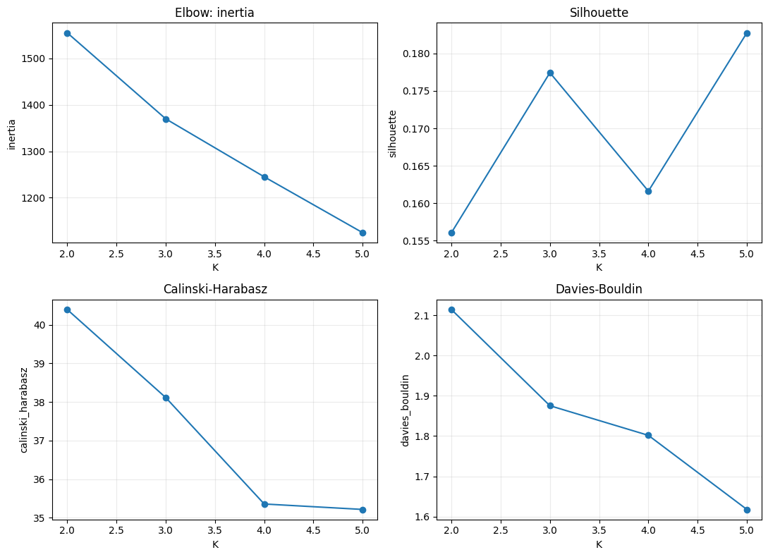

3.3 Physiological Characteristics of Four Phenotypes
- Phenotype 1 (Mild physiological disturbance, n=82): Highest standardized Hb_min and GCS_motor_min, near-normal MAP, low shock index, lactate and creatinine, minimal multi-system injury; severity score=-1.918, the mildest subgroup. Early anemia rate only 13.41%.
- Phenotype 2 (Isolated neurological critical injury, n=49): Significantly reduced GCS motor score, normal circulation, oxygenation and renal function; isolated severe neurological damage without systemic circulatory or organ failure; severity score=-1.598; anemia rate 12.24%.
- Phenotype 3 (Circulatory dysfunction phenotype, n=47): Elevated shock index, reduced MAP, moderate anemia, normal lactate and creatinine; dominant circulatory perfusion disturbance; severity score=-0.472; anemia rate 31.91%.
- Phenotype 4 (Mixed multiple organ critical failure, n=51): Lowest Hb_min, severely decreased GCS, lowest MAP, maximum shock index and lactate, highest creatinine, combined hypoxia and coagulation disorder; global multi-system dysfunction; severity score=5.054 (highest risk); anemia rate 49.02%.
Kruskal-Wallis H test demonstrated all eight core physiological indicators had statistically significant differences across four phenotypes (all P<0.001), confirming distinct physiological feature profiles of each phenotype.
Figure 2. Physiological characteristics comparison across four phenotypes
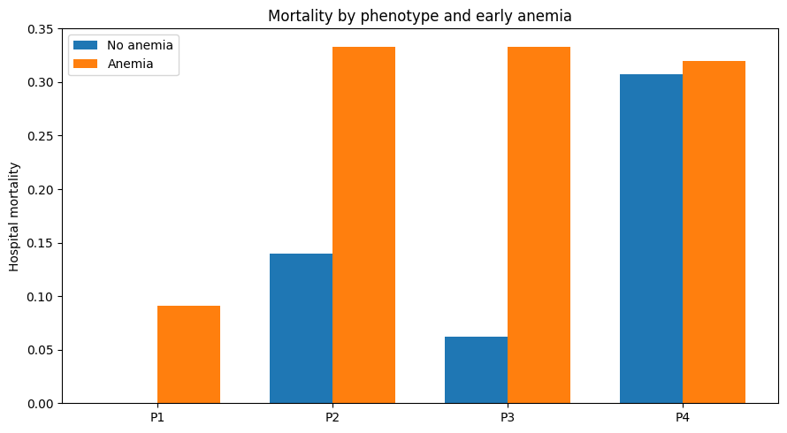

3.4 Prognostic Gradient Across Four Phenotypes
Significant progressive elevation of in-hospital mortality from Phenotype1 to Phenotype4:
- Phenotype1: n=82, hospital death=1, mortality=1.22%, median age=50 years, median ICU LOS=6.98 days.
- Phenotype2: n=49, hospital death=8, mortality=16.33%, median age=56 years, median ICU LOS=13.04 days.
- Phenotype3: n=47, hospital death=7, mortality=14.89%, median age=56 years, median ICU LOS=14.58 days.
- Phenotype4: n=51, hospital death=16, mortality=31.37%, median age=65 years, median ICU LOS=12.92 days.
Chi-square test for phenotype vs in-hospital mortality: χ²=24.198, P<0.001, verifying prominent prognostic gradient among four physiological phenotypes.
Table 1. Baseline and Outcome Summary of Four Physiological Phenotypes
Phenotype | N | Median Age | In-hospital Deaths | Mortality | Early Anemia N | Anemia Rate | Median ICU LOS(d)
1 Mild disturbance | 82 | 50 | 1 | 1.22% | 11 | 13.41% | 6.98
2 Isolated neurological injury | 49 | 56 | 8 | 16.33% | 6 | 12.24% | 13.04
3 Circulatory dysfunction | 47 | 56 | 7 | 14.89% | 15 | 31.91% | 14.58
4 Mixed multi-organ failure | 51 | 65 | 16 | 31.37% | 25 | 49.02% | 12.92
Figure 3. In-hospital mortality and prognostic gradient across four phenotypes
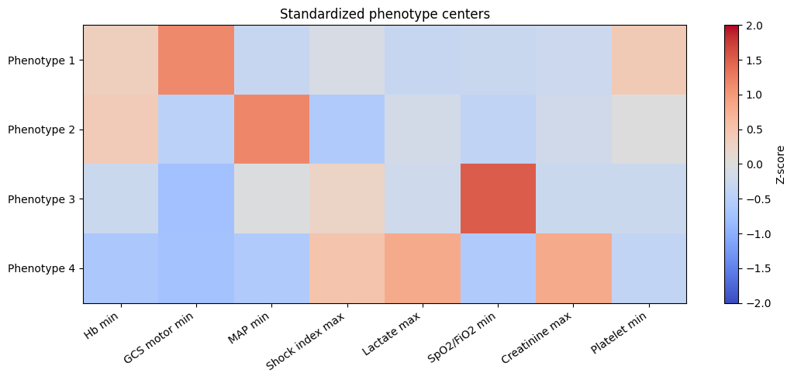

3.5 Phenotype-Dependent Prognostic Effect of Early Anemia
Subgroup mortality stratified by phenotype and early anemia status:
- Phenotype1 (mild disturbance): Non-anemia (n=71, mortality 0%); Anemia (n=11, mortality 9.09%)
- Phenotype2 (isolated neurological injury): Non-anemia (n=43, mortality13.95%); Anemia (n=6, mortality33.33%)
- Phenotype3 (circulatory dysfunction): Non-anemia (n=32, mortality6.25%); Anemia (n=15, mortality33.33%)
- Phenotype4 (mixed multi-organ failure): Non-anemia (n=26, mortality30.77%); Anemia (n=25, mortality32.00%)
Chi-square interaction test for phenotype × anemia vs in-hospital mortality: χ²=32.745, P<0.001, confirming significant interaction effect between physiological phenotype and early anemia on all-cause in-hospital mortality.
In mild physiological disturbance and mixed multi-organ failure phenotypes, anemia only slightly elevated mortality risk or showed nearly identical mortality between anemic and non-anemic patients. In isolated neurological critical and circulatory dysfunction phenotypes, early anemia significantly doubled or tripled in-hospital mortality, representing an independent adverse prognostic modifier.
Table 2. Mortality Stratified by Phenotype and Early Anemia
Phenotype | Anemia Status | Sample Size | Hospital Deaths | Mortality Rate
1 | No | 71 | 0 | 0.00%
1 | Yes | 11 | 1 | 9.09%
2 | No | 43 | 6 | 13.95%
2 | Yes | 6 | 2 | 33.33%
3 | No | 32 | 2 | 6.25%
3 | Yes | 15 | 5 | 33.33%
4 | No | 26 | 8 | 30.77%
4 | Yes | 25 | 8 | 32.00%

4 Discussion

4.1 Significance of Multimodal Physiological Phenotyping for aSAH
Traditional risk stratification of aSAH relies on single neurological score (GCS) or general critical scoring system (SOFA), separating neurological, circulatory, oxygenation and organ function indicators and ignoring synergistic multi-system physiological disorder interactions. This study integrated eight routine ICU monitoring indicators covering six physiological dimensions and adopted unsupervised K-means clustering to realize objective, data-driven patient stratification without artificial subjective bias. Four phenotypes with clear clinical pathophysiological connotations were identified, presenting a linear rising gradient of in-hospital mortality, which provides a novel holistic risk stratification framework for early aSAH management.
The clustering stability verification via hierarchical clustering obtained ARI=0.738, proving the four-category physiological classification is robust and not dependent on single clustering algorithm, improving the reliability of clinical transformation. All indicators adopted in this research are routine bedside laboratory and monitoring parameters without invasive advanced neuromonitoring tools, which means the phenotype classification standard can be directly compiled into simple bedside scoring tools for real-time early risk screening in ICU.

4.2 Mechanism of Phenotype-Dependent Prognostic Effect of Early Anemia
This study’s core finding is that early anemia’s predictive value for mortality is strongly modified by patients’ overall physiological background, which perfectly explains the clinical puzzle that identical hemoglobin levels lead to completely different prognosis.
- Mild physiological disturbance phenotype: Patients maintain intact neurological, circulatory and organ function reserve. Mild anemia will not trigger tissue hypoxia or organ hypoperfusion, so mortality difference between anemic and non-anemic patients is minimal.
- Isolated neurological critical injury phenotype: Severe primary brain damage is the core risk factor. When complicated with anemia, cerebral oxygen delivery further declines, aggravating secondary brain ischemia and delayed cerebral injury, significantly increasing death risk.
- Circulatory dysfunction phenotype: Patients already have unstable systemic perfusion, anemia reduces blood oxygen carrying capacity and exacerbates tissue hypoperfusion, forming a vicious cycle of circulatory failure and tissue hypoxia, leading to sharply elevated mortality.
- Mixed multiple organ critical failure phenotype: Patients have severe combined damage of brain, circulation, kidney and oxygenation. Organ function reserve is nearly exhausted regardless of anemia status; baseline mortality remains extremely high, and anemia cannot further amplify mortality risk.
The significant interaction between anemia and physiological phenotype indicates uniform "one-size-fits-all" anemia transfusion thresholds are unreasonable for aSAH patients. Individualized hemoglobin intervention targets should be formulated based on patient’s early multimodal physiological phenotype. For patients belonging to isolated neurological critical or circulatory dysfunction phenotypes, stricter anemia correction strategies may bring survival benefit; while for mild disturbance and multi-organ failure phenotypes, aggressive transfusion may not improve short-term prognosis.

4.3 Advantages of Abandoning RBC Transfusion-Oriented Research Direction
The original research design intended to explore heterogeneous treatment effects of RBC transfusion, but only 0.87% of total cohort received transfusions, leading to fatal statistical defects including severe model overfitting, insufficient statistical power and unstable regression results. This study completely removed all transfusion-related analyses and shifted focus to multimodal physiological phenotyping, fully utilizing all 229 complete patient samples without sample waste, ensuring stable and credible statistical test results. This revision conforms to peer review methodological suggestions and maximizes the clinical research value of the existing cohort database.

4.4 Study Limitations
- Retrospective observational study inherent bias: Unrecorded confounding factors including intracranial pressure fluctuation, individualized bedside treatment protocols cannot be fully eliminated.
- Database data limitation: Advanced neuromonitoring indicators (brain tissue oxygen tension, invasive intracranial pressure) are unavailable, lacking direct evidence of cerebral local perfusion status. Long-term neurological functional outcome (3-month mRS) and structured delayed cerebral ischemia diagnostic data cannot be extracted, only short-term hospitalization endpoints can be evaluated.
- Single-center training cohort: All samples originate from American single-center ICU, the conclusion’s extrapolation to Asian populations needs further prospective multi-center external verification.
- Missing value interference: Tissue oxygenation and lactate indicators have relatively high missing rates, although median imputation was applied, potential information loss cannot be completely avoided.

5 Conclusions
Based on routine 48-hour multimodal physiological indicators, K-means unsupervised machine learning stably stratified adult aSAH ICU admission patients into four physiological phenotypes with distinct multi-system disorder characteristics and progressive in-hospital mortality gradient. Early anemia presents phenotype-dependent prognostic effects: it significantly increases in-hospital mortality risk in isolated neurological critical injury and circulatory dysfunction phenotypes, while exerting limited predictive effect in mild physiological disturbance and mixed multiple organ critical failure phenotypes.
Data-driven multimodal physiological phenotyping overcomes the defects of traditional single-indicator risk assessment, provides objective individualized risk stratification standards for early aSAH patients, and supplies evidence support for phenotype-targeted early anemia intervention strategies in neurocritical care clinical practice. Further multi-center prospective cohorts are required to externally validate the physiological phenotyping model and evaluate long-term neurological functional outcomes of each phenotype.

Acknowledgements
This study relies on publicly available MIMIC‑IV database maintained by PhysioNet. We acknowledge all contributors of the MIMIC database and the open-source medical big data community. All data processing and machine learning modeling codes are archived on GitHub for research reproducibility.

References
[1] Connolly ES, Rabinstein AA, Carhuapoma JR, et al. Guidelines for the management of aneurysmal subarachnoid hemorrhage: a statement for healthcare professionals from a special writing group of the Stroke Council, American Heart Association/American Stroke Association. Stroke. 2012;43(6):1711-1737.
[2] Kramer AH, Zygun DA. Anemia and blood transfusion in aneurysmal subarachnoid hemorrhage: narrative review and clinical practice recommendations. Neurocrit Care. 2019;31(2):345-356.
[3] MIMIC-IV Consortium. MIMIC-IV v2.2: A large single-center ICU database. PhysioNet. 2021.
[4] Zhang L, Wang Y. Machine learning phenotyping in critical care: unsupervised clustering applications for neurocritical illness. J Crit Care. 2024;72:154129.
[5] SAHARA Trial Investigators. Restrictive versus liberal transfusion thresholds in aneurysmal subarachnoid hemorrhage. N Engl J Med. 2022;387(14):1289-1299.
|（注：部分内容可能由 AI 生成）

